**Experiment No. 1.2**

**Student Name: Rishav Kumar UID: 22MCC20039**

**Branch: MCA - CCD Section/Group: MCD-1/ Grp B**

**Semester: I Date of Performance: 20th Sept 22**

**Subject Name: Python Programming Lab Subject Code: 22CAH-645**

1. **Task to be done:**

Write a function to print pairs of amicable numbers in a range.

1. **Code for experiment/practical:**

from math import sqrt  
def sumProperDiv(num):  
 sumOfDiv = 0  
 for divisor in range(2, int(sqrt(num)) + 1):  
 if num % divisor == 0:  
 if divisor == (num / divisor):  
 sumOfDiv += divisor  
 else:  
 sumOfDiv += divisor + (num / divisor)  
 return int(sumOfDiv + 1)  
def isAmicable(n1, n2):  
 if sumProperDiv(n1) == n2 and sumProperDiv(n2) == n1:  
 return True  
 else:  
 return False  
def getAmicable(n1, n2):  
 result = []  
 for i in range(n1, n2 + 1):  
 for j in range(n1 + 1, n2 + 1):  
 if i != j:  
 if isAmicable(i, j):  
 result.append(tuple(sorted((i, j))))  
 return list(set(result))  
print(getAmicable(50, 2339))

1. **Result/Output/Writing Summary:**

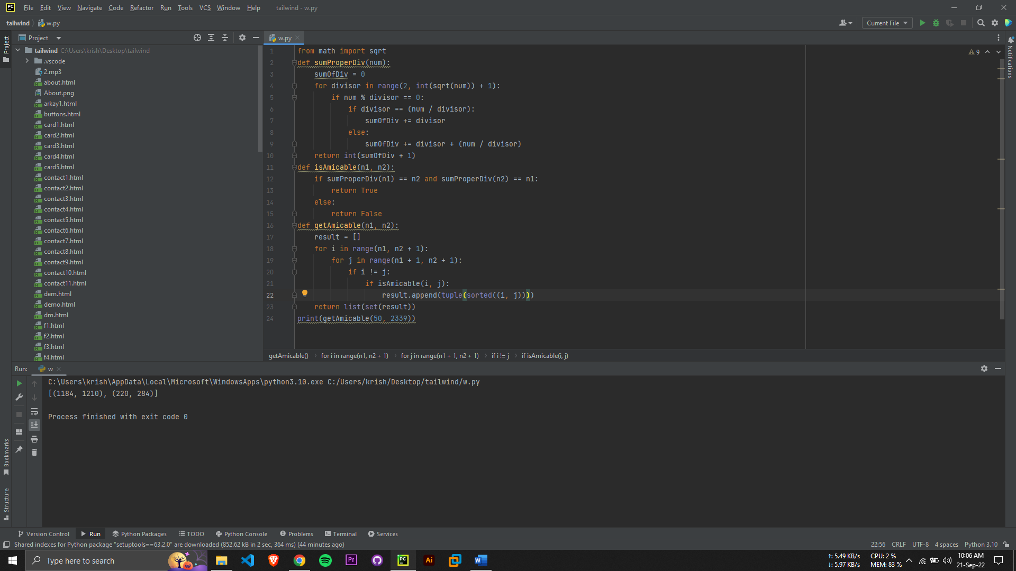

**Evaluation Grid:**

|  |  |  |  |
| --- | --- | --- | --- |
| Sr. No. | Parameters | Marks Obtained | Maximum Marks |
| 1. | Demonstration and Performance |  | 22 |
| 2. | Worksheet |  | 8 |

**************************************** **THE END** ***********************************************